**CIRCUIT DESIGN:**

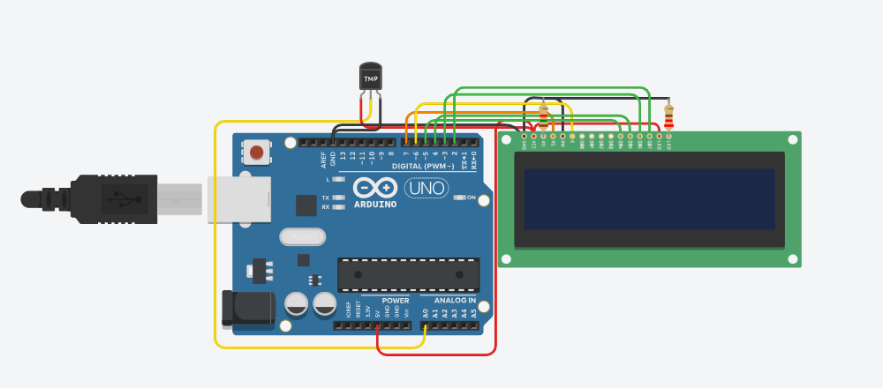

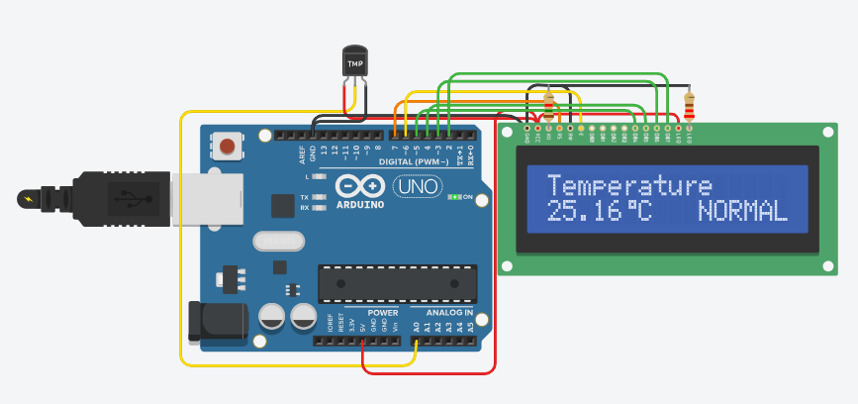

**CODE:**

#include <stdio.h>

#include <stdbool.h>

bool isButtonPressed() {

static int count = 0;

return (++count % 1 >= 1); // Simulate button press every 5th call

}

float getTemperature() {

return 25.16; // Simulated temperature

}

int main() {

int buttonPressCount = 0;

bool lastButtonState = false;

while (1) {

bool currentButtonState = isButtonPressed();

if (currentButtonState && !lastButtonState) {

buttonPressCount++;

printf("Button pressed %d times\n", buttonPressCount);

}

lastButtonState = currentButtonState;

printf("Temperature: %.2f°C\n", getTemperature());

for (volatile int i = 0; i < 100000; i++); // Simple debounce

}

return 0;

}

**OUTPUT DEMONSTRATION:**

